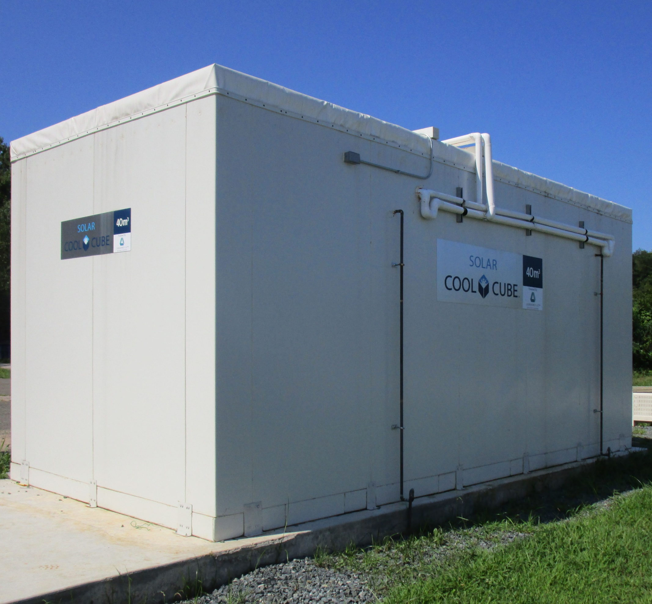   |   SOLAR COOL CUBE 20m³ INSTALLATION MANUAL

Contents
FOREWORD 2
CUSTOMER INFORMATION PAGE 3
ARRIVAL GUIDANCE 4
ARRIVAL INSPECTION CHECKLIST 5
INSTALLATION WORK FLOW 6
SITE PREPARATION 7
COOL CUBE SET-UP 9
SOLAR ARRAY INSTALLATION 14
INSTALLING MODULES TO RAILS 17
INSTALLING BATTERY STORAGE 21
BATTERY BASELINE WORKSHEET Complete for reference 22
OVERVIEW OF SYSTEM WIRING 23
WIRING SOLAR MODULES 24
WIRING THE COMBINER BOX 25
DETAIL OF COMBINER BOX WIRING including PV 26
INSTALLATION OF POWER PANEL SYSTEM AND CHARGE CONTROLLER 27
Connecting Solar Combiner Box to Mini-Panel & Charge Control 28
Wiring Battery Connections to MMP Panel 30
Wiring AC Input/Output Connections (THIS PAGE SHOULD BE SKIPPED) 32
MMP/INVERTER SYSTEM GROUNDING 33
INSTALLATION CHECKLIST 34
FUNCTIONAL TEST CHECKLIST/COMMISSIONING PROCEDURE 36
INSTALLING BATTERY MONITOR 38
PROGRAMMING SYSTEM CONTROL PANEL 39
MAINTENANCE GUIDE 41
MAINTENANCE LOGS (make copies of this sheet and use weekly) 42
SERVICE LOG (make copies of this sheet and use to report issues) 43
Technical Contacts 44

FOREWORD

Welcome to A World of Enhanced Opportunities
A truism we hope defines the vision we have as you begin the journey with
the Solar Cool Cube.

As you will soon discover, the variation in the Solar Cool Cube’s capabilities will provide you with possibilities in expanding economic and developmental opportunities within your community.

What we have is a cooperation with you, the client, and DGridEnergy to leverage solar energy technologies towards building a hub for your community’s developmental growth.

Solar Cool Cube usage has traversed medical and agricultural industries, to telecommunications and now, enhancing data collation. DGrid Energy looks forward to growing this relationship with you and will continue to provide you with the knowledge of the opportunities the Solar Cool Cube provides you.
... welcome to our World of Opportunities.

CUSTOMER INFORMATION PAGE

Client Name: Address:
Primary contact:
Secondary contact:
Primary Telephone contact: Secondary Telephone contact:
Primary E-mail contact: Secondary E-mail contact:
Primary Fax contact: Secondary Fax contact:
INSTALLATION INFORMATION
Solar Cool Cube Serial Number: Model Number and Options:
Refrigeration Unit Serial Number:
Solar Module Serial Number: Battery Module Serial Number 1:
Other Serial Number:
Additional Information: Geo-location Information:
Compressor Serial Number 1:

ARRIVAL GUIDANCE

Congratulations!

Now What?

Contact DGrid Energy to inform us that your Solar Cool Cube package has arrived.

Visually inspect the container for
any damage and take photos of
any identified.

Follow the Arrival Checklist that
is on the following page and
e-mail a copy to DGrid Energy
Your Solar Cool Cube has arrived in the container.

Before you go ahead and unpack the unit, there are some checks that you need to complete to ensure that your unit has not been damaged in transit.

Please use the checklist on the next page to visually inspect the unit and subsequently document any evidence of damage that may have occurred during transit.

Take photographic evidence of any visible damage and ensure to included it in the documentation that you will send to DGrid Energy for the delivery confirmation procedure.

ARRIVAL INSPECTION CHECKLIST
Visual Inspection of Exterior
Please ensure to capture photographic evidence of any damage you witness, whether external or internal to the
container. This information is important for following up with the required insurance coverage.
YES NO
• Is there any visible damage to the container? (A dent to the side of the container;
any puncture to the container wall or edges; fully corroded section of the
container?)

• Is there any visible evidence of leakage of fluids from the container? (Please
describe the color of any leakage evidenced)

• Does the container have any evidence of being forcibly opened?
Please describe any information you selected ‘Yes’ in the detailed description sections.

Visual Inspection of Interior
• Is there any visible evidence that the components have moved from their original
packed states?

• Does some of the packaging appear to have come undone or been unpackaged?

• Is there any visible evidence inside the container of any leakage of fluids?
Please describe any information you selected ‘Yes’ in the detailed description sections.

Detailed Description
• Please describe in detail any damage noted.

Please ensure to capture photographic evidence of any damage you witness, whether external or internal to the
container. This information is important for following up with the required insurance coverage.

INSTALLATION WORK FLOW
Prepare Site- Concrete Pad, Set Poles, Roofing Structure


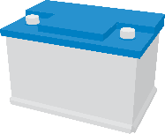
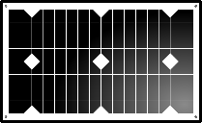
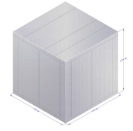
- All items marked with an asterisk can be installed at the same time. DO NOT MAKE final electrical connections until all pieces are installed.
Set-Up Online Monitoring
Commission System and Bring Refrigeration Online
Program Power System
Wire System Components & Install Power Center *
Assemble Battery Storage *
Install Solar Array on Roofing Structure *
Assemble Refrigeration Unit per Installation Instructions *

SITE PREPARATION

Tool Guide and Resource Recommendations

Care: Before assembly, layout the Solar Cool Cube parts on a waterproof tarp for easy access and to prevent any damage to the sections prior to installation

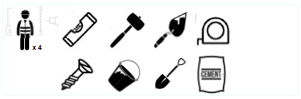
Pre-Assembly Preparation

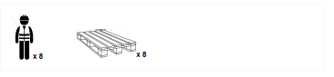
For Off-Loading

For Assembly
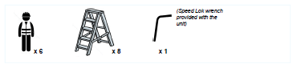

Items Required
Level
Trowel
Shovel
Cement

STEP 1: Pour the concrete slab or prepare the base below the Solar Cool Cube.
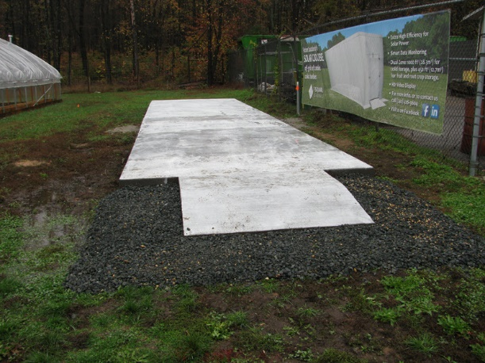
If a concrete slab must be prepared. This should be 4-6 inches (100-150 mm) thick. It should
be above ground level by at least 2 inches (50 mm). (Dimensions below item 3.)

2. Post holes may be included in the concrete structure for building roof supports, or such supports may be framed and anchored on the surface of the pad or may be constructed separately
outside the pad.

3. The solar panel support and roof system must be built. An example is given. The angle of the
roof surface and whether it is flat or A frame.
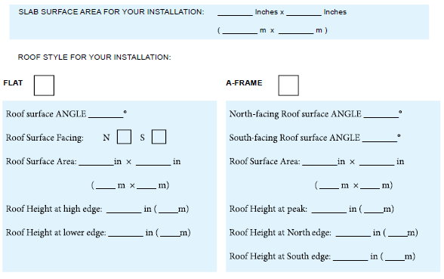

COOL CUBE SET-UP
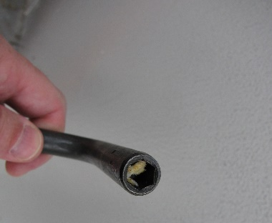
SPECIAL NOTE: During installation, the special wrench provided with the Cool Cube to turn the Speed-Loks may become clogged with foam, remove with a screwdriver

STEP 1- Fridge Floor Assembly

Parts Required:
Front Floor Panel
Inside Floor Panels
Back Floor Panels

Tools Required:
Speed-Lok wrench provided with the unit

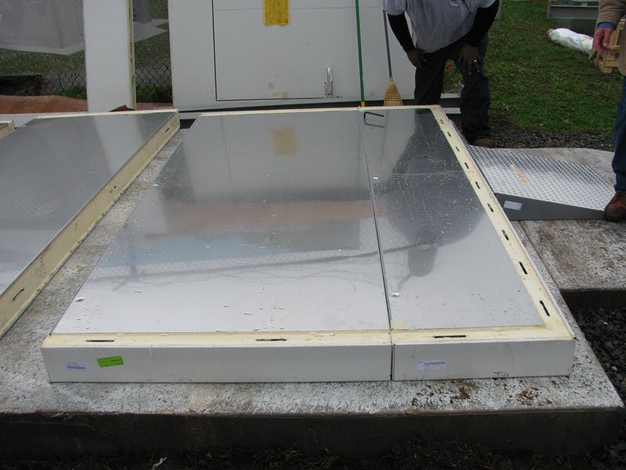
1. Lay the floor parts on the concrete slab. The silvered surface and interlocking Speed-Lok slots [circled] should face upwards.
2. Position the “Entrance-side” part first and work backwards to the rear of the unit, connecting each part to the other using the provided torque wrench. (After each part is connected to the preceding one, ensure the joint is closed tight between them and has no gap)
3. Check that the floor is level and making solid contact with the slab.

Step 2: Front Door and Front Wall Assembly

Parts Required:
Corner Panels
Wall Panels (either side of the door)
Door Assembly

Tools Required:
Speed-Lok Wrench

1. First, install the Left-Corner of the Front Wall, make sure to secure it to the Floor Panel with the Speed -Lok. Ensure to use a post-level to check that the corner is vertical.
2. Next, install the Front-Door ensuring to secure it to the Floor Panel and the Left-Corner panel, as shown below.
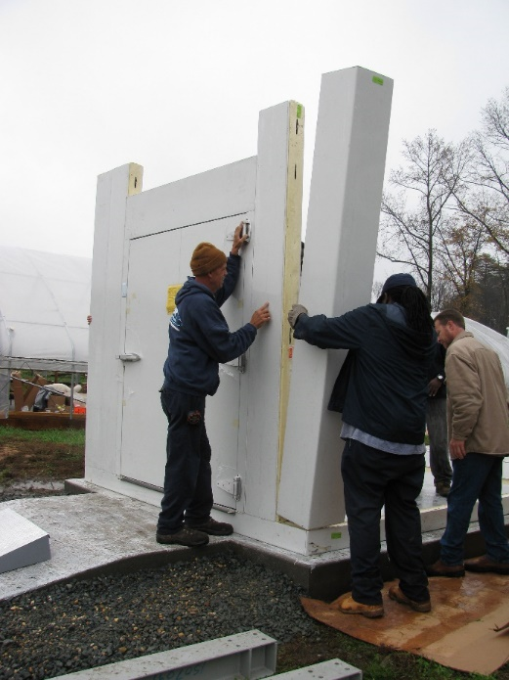
3. Finally, secure the Right-Corner to the Front-Door panel.
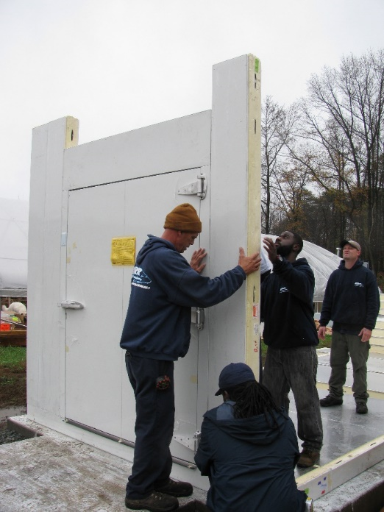
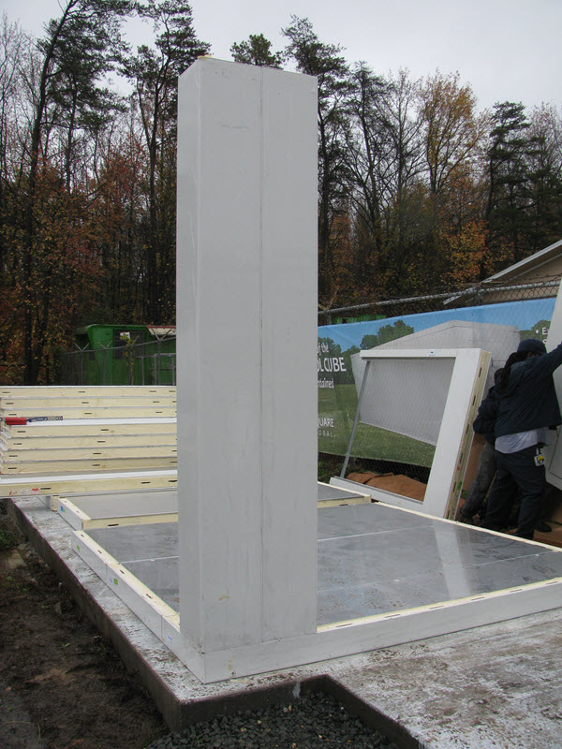

Post Assembly Checklist:
If the part is fitted correctly you should:
- Not see any joint gaps between successive floor & wall panel joints
- Open the door freely without any scraping of the Solar Cool Cube unit’s floor
- No open joints between the vertical panels as well as between the floor panel and vertical panels.

Step 3- Side Walls and Door Top Assembly

Parts Required:
Wall Panels (Side)
Door Transom Panel
Tools Required:
Speed-Lok Wrench

1. Connect the Side Wall Panels starting from the front (the door end) to the back.
2. Ensure to connect the Door Top Panel as highlighted in the picture above. This will be critical
for the assembly of the unit’s roof.
3. When the vertical panels are in place, any joint between panels that you are facing from the
outside will have the pin recesses on the right side and the hook recesses on the left side of
the joint (see adjacent illustration).
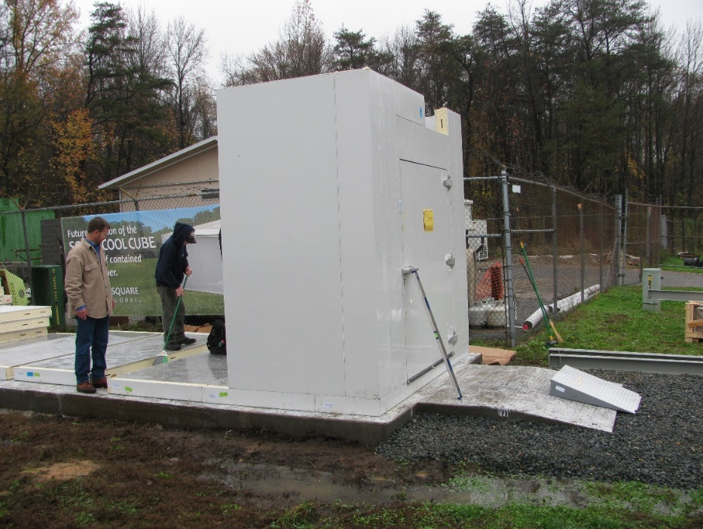
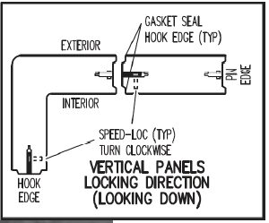
Post Assembly Checklist:
If the part is fitted correctly you should:
- Not see any joint gaps between successive panel joints
- Ensure the correct sequence of Side Wall Panels with the silvered surface facing inwards.

Step 4- Roof Assembly

Parts Required:
Front Ceiling Panel
Inside Ceiling Panel(s)
Back Ceiling Panel
Tools Required:
Speed-Lok Wrench

1. Once the sides are up, the Roof panels can be installed. Work from the front of the unit, backwards.
2. Speed Lok the Roof Panels to the Side Walls as well as to their adjacent Roof Panels.
3. Finally, secure the Right-Corner panels to the Front-Door panel.
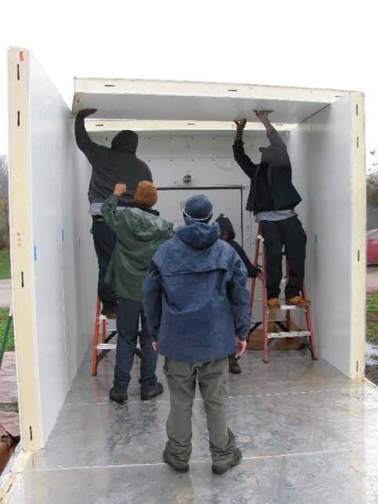
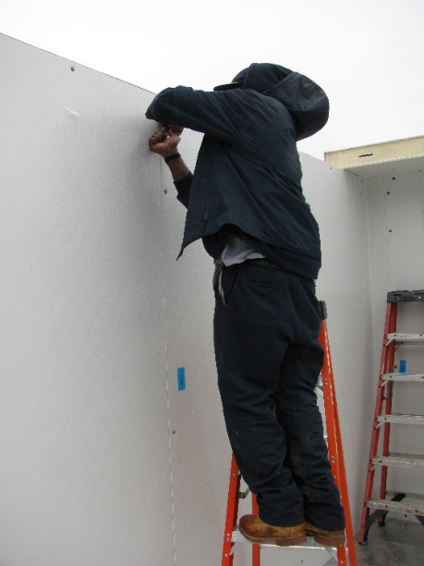
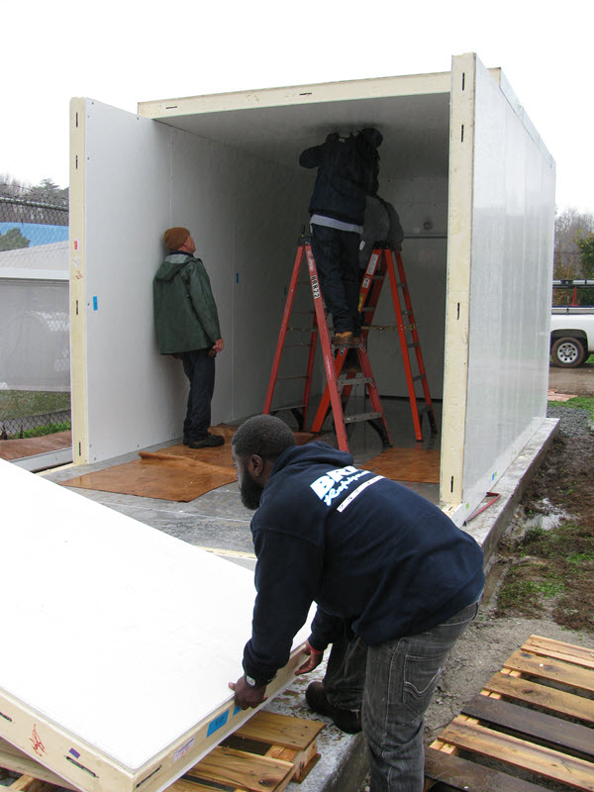
Post Assembly Checklist:
If the part is fitted correctly you should:
- Not see any joint gaps between successive roof panel joints with side wall panel joints and between adjacent roof panels

Step 5- Back Wall and Roof Assembly

Parts Required:
Wall Panels (Back)
Back Ceiling Panel
Corner Panels

Tools Required:
Speed-Lok Wrench

1. The Back Wall panel, Back Corner Panels and Cooling Unit Roof Panel will now be installed.
2. Depending on your Solar Cool Cube model, the Cooling Unit Roof Panel weighs at least 160
kilograms, so needs to be handled with care and extra labor.
3. After the Back Wall End panels are locked, place the Cooling Unit Roof panel (see detail below) and ensure to tighten the Speed Lok.
4. Complete the back of the unit by installing the Back Wall panels. Ensure the Speed Lok of the
entire back wall has clicked firmly in place.

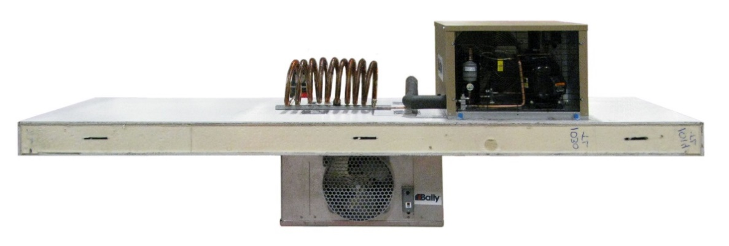
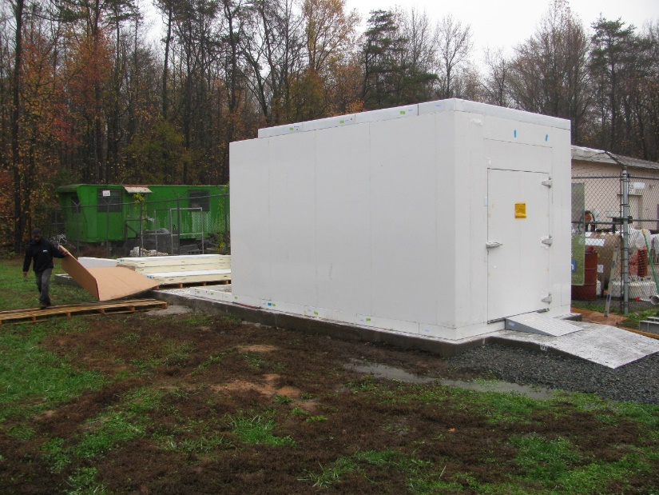

SOLAR ARRAY INSTALLATION
Components Needed:
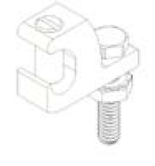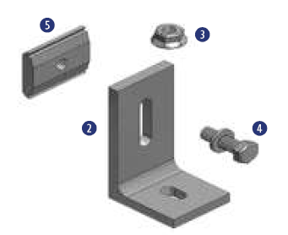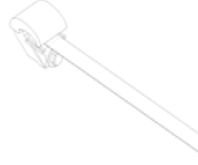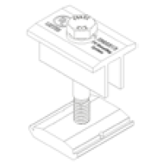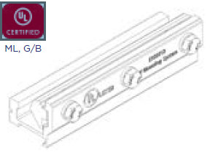
Grounding Lugs L-Feet End Clamp Mid Clamp Rail Splice
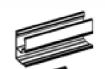
Rails Solar Modules x 12

Tools Needed:
Hammer
Roof Marking Crayon or Chalk Line
Level
Drill: 3/16” Pilot Drill Bit
5/32” Allen Key
Wire Strippers
Pitch Meter
Roof Sealant
Torque Wrench
Socket Wrench with ½” Socket

Installation:
- Mark Roof Attachment Locations on Roof with Chalk or Roof Marking Crayon. X should be above a roofing timber or rafter. See typical example below, this may not match the layout needed for your install.
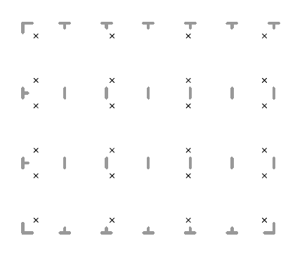
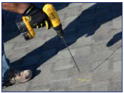
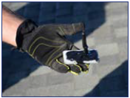

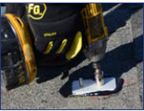
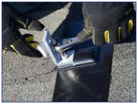

Drill Pilot Holes in each X marked on roof.
Apply sealant to bottom of base

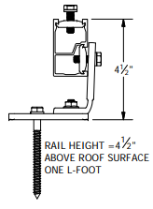
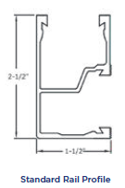
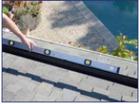
Attach Rails to L-Foot using slide channel nut inserted into rail profile. Tilt the channel nut into the side channel of rail, and tilt to snap into place. Lift the channel nut into highest point on the L-Foot and tighten. Level the bottom rail of the array to the roof and make any adjustments necessary.
- Attach L Foot to Base: Tighten Flange Nut over L Foot: 10-16 ft lbs
- Attach Base to Roof: 5/16” Lag Screw, minimum 2.5” of embedment

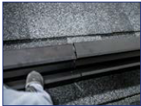


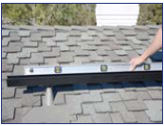
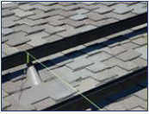


Level top rail by moving string down the length of rail, matching the pitch
- Align top rail with bottom and adjust for roof pitch using a string. Adjust top rail if necessary
- Tighten with socket wrench
- Lift up on splice insert and engage upper lip of rail channel and tighten bolts by hand to secure into rails
- Set rail splice assembly into the side channel of rail, centered between the two rail ends
- SPLICE RAILS- Align sections of rails

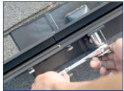
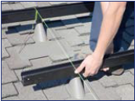

- Tighten all racking hardware to 10-16 ft-lbs
11. Level remaining rails to string line starting from the middle rail

INSTALLING MODULES TO RAILS
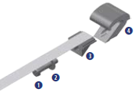
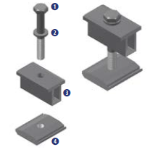
One each of:
- Bolt
- Split Lock Washer
- Mid Clamp
- Channel Nut
One each of:
- Bolt
- Split Lock Washer
- Self-Adjusting Top
- Self-Adjusting Bottom
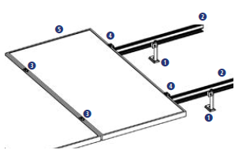
Module Assembly Overview
End Clamp Assembly
Mid Clamp Assembly
- Roof Attachment Points- L Fee
- Rails
- Mid Clamps
- End Clamps (these are positioned at end of rows)
- PV Modules (panels)

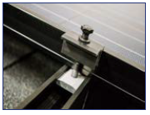
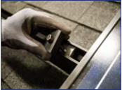
- Slide clamp flush to module

- Snap channel nut into the top channel or rail

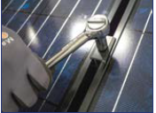
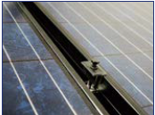

- Tighten hardware, 10-16 ft lbs
- Place next module flush to other side of mid clamp, keeping wiring exposed outside of modules

Install the grounding lug prior to installing the last module in each row.

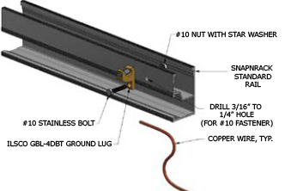

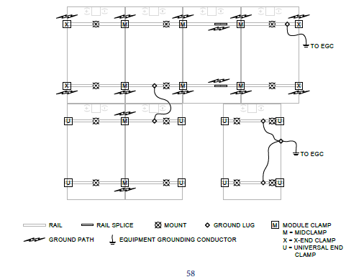

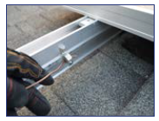
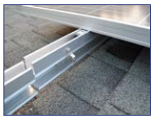

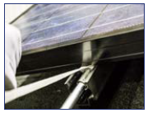
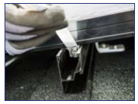
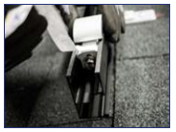
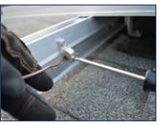
- Use pull tab and pull away from module to engage clamp. Tighten hardware.
- Lift module and slide the end clamp past the lip of the bottom of the module
- Slide end clamp into the end of the rail
- Tighten set screw to clamp ground wire
- Place grounding wire through slot
- Drill and deburr a 1/4" hole in back side of rail for lug. Place bolt through hole and attach lug assembly. ONE RAIL PER MODULE ROW

INSTALLING BATTERY STORAGE
EQUAL LENGTHS

BATTERY WIRING
!!!IMPORTANT!!!
DO NOT CONNECT FINAL POSITIVE AND NEGATIVE INVERTER CABLES UNTIL POWER PANEL SYSTEM IS INSTALLED. DO NOT TOUCH POSITIVE BATTERY CABLE TO NEGATIVE. CRITICAL DC CURRENT CAN OCCUR.
BATTERY INSTALLATION
¼” of airflow around each battery
3 series/parallel strings of 8 batteries
Each are 6V, 400Ah
Wired into Parallel:
1200Ah @ 48V

EQUAL LENGTHS

+
+
+
+
+
+
+
+
+
+
+
+
+
+
+
+
+
+
+
+
+
+
+
+
-

BATTERY BASELINE WORKSHEET
Complete for reference
Within the first week of operation, complete and keep this worksheet for reference on system performance:

Put battery system on a full charge cycle and record the following parameters (baseline readings):
- Charger Amperage Output: ________________________________________________________

- Absorption Voltage at Battery Terminals: _____________________________________________

- Float Voltage at Battery Terminals: __________________________________________________

- Voltage of each battery when charger is in float mode: __________________________________

- Ambient Temperature:

Allow the battery system to discharge until it reached the low voltage disconnect, and record the following parameters:

- Run Time: ______________________________________________________________________

- Capacity Delivered: ______________________________________________________________

- Average DC Load (Amps): _________________________________________________________

- Endpoint Voltage at Battery Terminals: ______________________________________________

RETURN BATTERIES TO FULLY CHARGED CONDITION AS SOON AS POSSIBLE

OVERVIEW OF SYSTEM WIRING

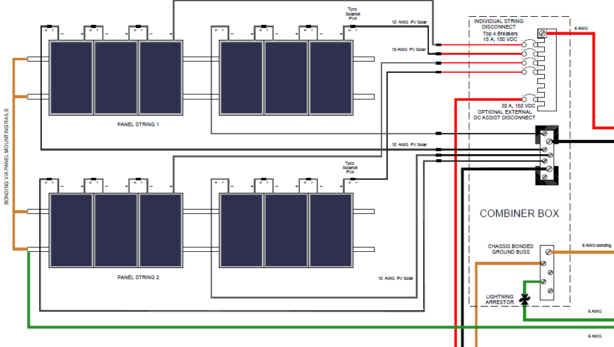

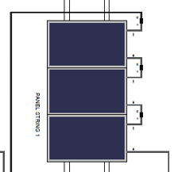
WIRING SOLAR MODULES

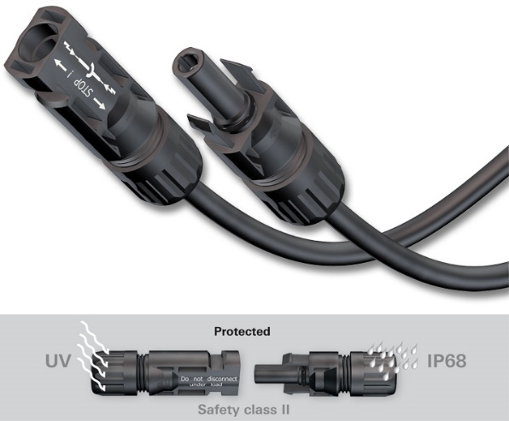
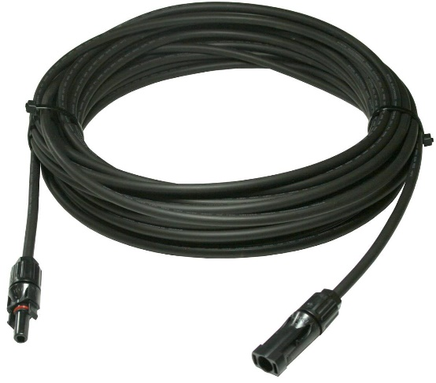
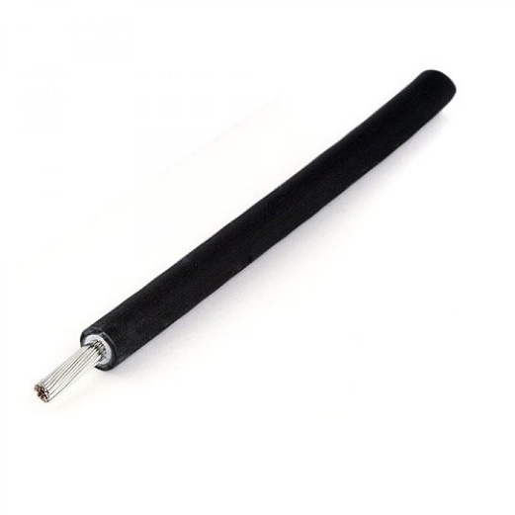
- Repeat this process 4 times. (see diagram on page 13)
Use wire ties to affix to rails

- At the solar array, connect 3 modules together by connecting the male to female ends of the connectors
- Locate 4, Solar Cables, these will be used for final connection to combiner box
4. Cut each cable to length and strip end. Measure before cutting so that they reach combiner box. Run bare cables in conduit to power shed.

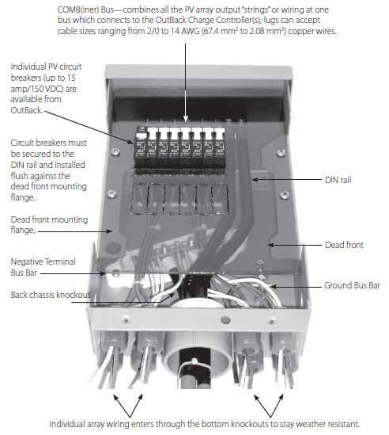
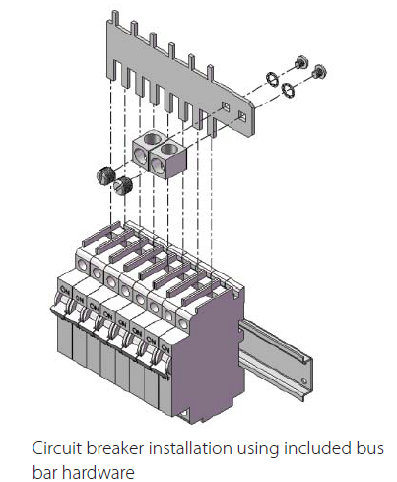
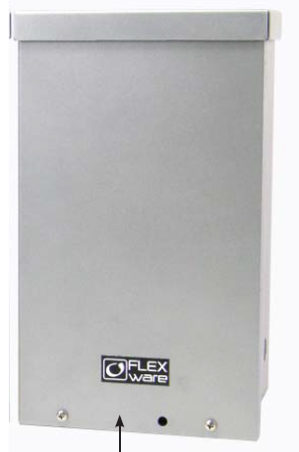
WIRING THE COMBINER BOX

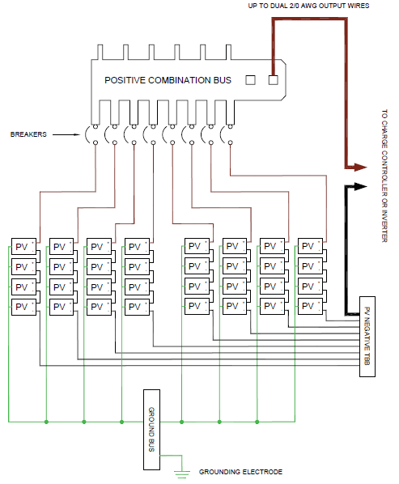
DETAIL OF COMBINER BOX WIRING including PV

INSTALLATION OF POWER PANEL SYSTEM AND CHARGE CONTROLLER
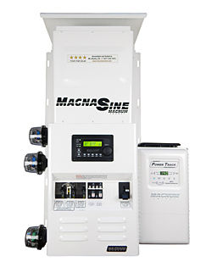
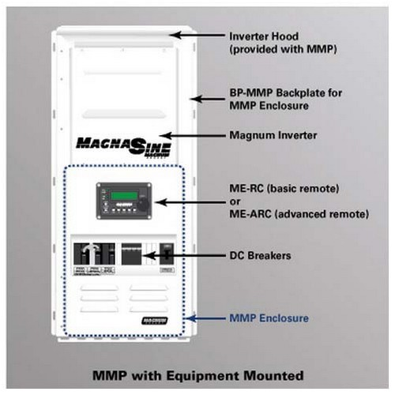

Parts Included:

- Pre-wired inverter mini-panel system with 1, charge controller
- RJ14 extension cable
- 6’ network cable
- 4, 8-32 x ½ black, Philips head screws
- 6’ remote cable
- 3/8-16 x 1” bolt
- 3/8” split lock washer

Materials Needed:

- Conduit, strain-reliefs and appropriate fittings
- Electrical Tape
- Conductors/cables for wiring
- ¼” mounting bolts and lock washers
- Wire ties

Tools Needed:

- Screwdrivers
- Drill and drill bits
- Level
- Torque wrenches
- Insulated Pliers
- Pencil
- ½” Wrench
- Ratchet Drive
- Wire Cutters/Strippers
- Multimeter

Your Magnum Power Panel system has come pre-wired and mounted on a back panel. This panel needs to be installed with at least 3” on either side for proper ventilation. Allow for enough room on either side for wire runs to the mini-panel as well as from the batteries. The panel system should be installed close to the battery bank to avoid long wire runs, but preferably not above the batteries if they are not in an enclosure.

Connecting Solar Combiner Box to Mini-Panel & Charge Control
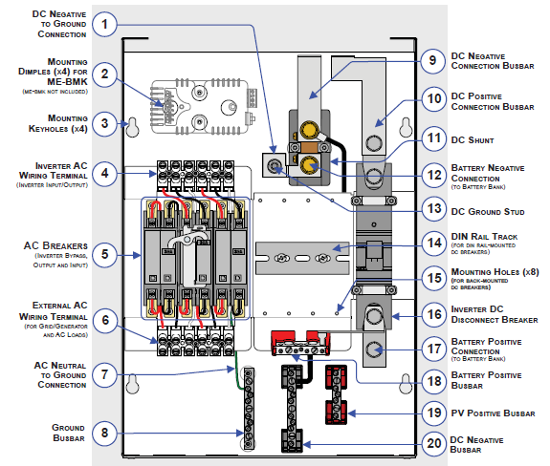

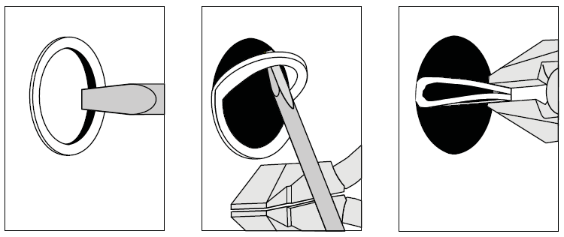
There are several knock-out locations available for running conduit, choose the ones preferable to your particular installation. To remove knockouts, follow the diagram

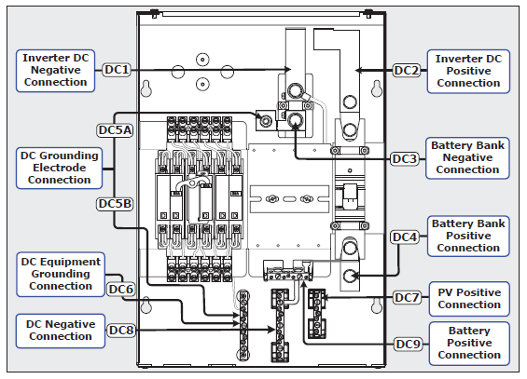
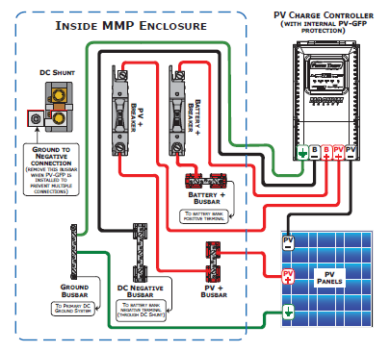
PV and Charge Control Wiring Connection Points:

WARNING! BEFORE MAKING ANY CONNECTIONS, MAKE SURE THAT ALL BREAKERS ARE SWITCHED TO THE OFF POSITION!
Review the diagram on page 28 and page 29.
- Wire the PV Positive connection from the combiner box to DC7.
- Wire the PV Negative connection from the combiner box to PV- input on the charge control input
- Wire the PV Ground to the Ground BusBar

Wiring Battery Connections to MMP Panel

WARNING! BEFORE MAKING ANY CONNECTIONS, MAKE SURE THAT ALL BREAKERS ARE SWITCHED TO THE OFF POSITION! LETHAL CURRENTS WILL BE PRESENT IF THE POSITIVE AND NEGATIVE CABLES ATTACHED TO THE BATTERY BANK TOUCH EACH OTHER.

DO NOT CONNECT THE DC WIRES TO THE BATTERY BANK UNTIL 1) All DC, AC and Accessory Wiring are completed; 2) the correct DC and AC overcurrent protection has been installed and, 3) the correct DC voltage and polarity have been verified. Reverse polarity wiring will destroy the inverter system. Use a multimeter to double check and mark all connections properly.

- Route the DC cables from the battery bank- NOT CONNECTED TO THE BATTERY- and connect them to the MMP enclosure as illustrated below. Make sure to stack the connections correctly. Secure and tighten all connections.
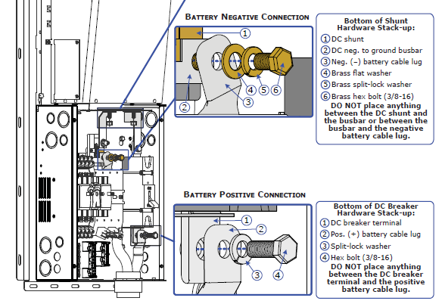

- Route and appropriately sized DC Grounding Wire (GREEN or bare wire) from the inverters DC ground terminal and from the battery bank enclosure to the DC ground busbar in the enclosure.

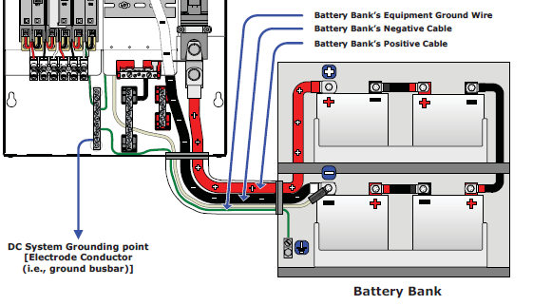

DO NOT MAKE THESE CONNECTIONS UNTIL ALL WIRING WITHIN THE PANEL SYSTEM IS COMPLETE!

Wiring AC Input/Output Connections (THIS PAGE SHOULD BE SKIPPED)

The enclosure allows you to permanently wire the AC loads to the inverter system. This would be used for the CoolCube refrigeration system and any additional AC loads needing to run from the system (lights, cellphone charging, weather station).

AC Ground Connections: The grounding busbar allows AC grounds to be connected to a common point. A neutral to ground connection is provided in the MMP enclosure. If this is provided elsewhere within the AC system, the connections must be disconnected.

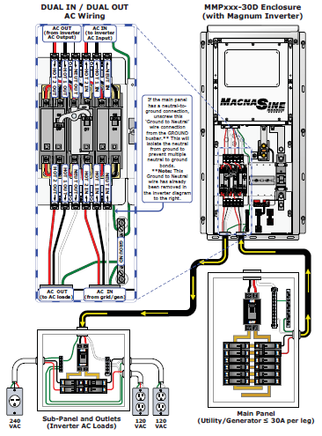

MMP/INVERTER SYSTEM GROUNDING

This system uses both AC and DC electrical systems, EACH electrical system is required to be properly connected to a permanent, common “ground” or “earth” reference. There are two types of grounding: Electrical System and Equipment.
Electrical System Grounding: System grounding takes one of the current carrying conductors (Grounded Conductor – GC) and attaches it to the common ground point (Ground BusBar- GBB), usually by a System Bonding Jumper (SBJ) in each electrical service disconnect panel. On the AC side, that is the neutral conductor (GC-AC); on the DC side, it’s the negative conductor (GC-DC). The closer the grounding connection is to the source, the better the protection from high voltage surges due to lightning.
Equipment Grounding: The exposed metal parts of the equipment in the system usually don’t carry electricity. However, if the exposed metal becomes electrified by a live wire, a person touching this live part could complete the electrical circuit and receive a shock. Equipment grounding prevents shock by connecting all the exposed metal parts of equipment (via Equipment Grounding Conductors – EGC) together at a common ground point (Ground BusBar – GBB). This common ground point—installed in the service disconnect panel for each electrical system (AC and DC)—is then connected (via Grounding Electrode Conductor – GEC) to the common ground reference, such as a ground rod (Grounding Electrode – GE). This connection to earth is made at only one point in each electrical system; otherwise, parallel paths will exist for the currents to flow. These parallel current paths would represent a safety hazard and are not allowed in installations wired per the NEC/CEC.
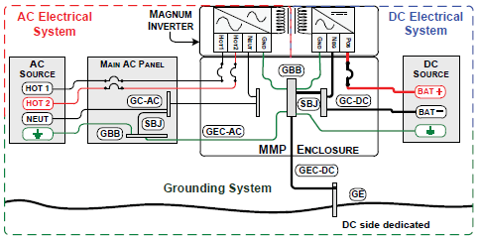

INSTALLATION CHECKLIST
Use this checklist as a final review to ensure all essential steps to install the MMP enclosure have been completed before proceeding with the functional test.
Mounting
- The MMP enclosure/inverter system is securely mounted in a clean, dry, and ventilated area.
- The system is not mounted in the same enclosure as maintenance-free or vented type batteries.
- The MMP enclosure is mounted in a ‘vertical only’ position.
- There is adequate clearance to access the front and to view/adjust the remote (if installed).
DC Wiring
Inverter Side with Magnum Inverter
- The inverter is correctly placed onto the MMP enclosure with the inverter’s DC terminals attached to the tops of the DC negative busbar and the DC positive busbar inside the MMP enclosure.
Inverter Side without Magnum Inverter:
- DC cable is routed and attached from the inverter’s DC positive (+) terminal to the DC positive connection at the top of the DC breaker inside the MMP enclosure.
- An appropriately sized DC cable is routed and attached from the inverter’s DC negative (–) terminal to the DC negative connection at the top of the DC shunt inside the MMP enclosure.
Battery Bank Side:
- An appropriately sized DC cable is routed and attached from the positive (+) battery terminal to the bottom battery bank connection of the DC disconnect breaker inside the MMP enclosure.
- An appropriately sized DC cable is routed and attached from the negative (–) battery terminal to the bottom battery bank connection of the DC shunt inside the MMP enclosure.
- The DC cable connections and DC hardware are stacked and torqued correctly.
AC Wiring
In and Out of Inverter:
- The AC wires are appropriately sized and routed from the INVERTER AC TERMINAL BLOCK (inside MMP enclosure) to the inverter’s AC input/output terminals.
To Main AC Electrical Panel:
- The AC wires are appropriately sized and are routed from the grid/gen side of the EXTERNAL AC TERMINAL BLOCK (inside MMP enclosure) to the circuit breaker in the main AC electrical panel powered by the utility or generator (i.e., main panel).
To Inverter AC Load Panel:
- The AC wires are appropriately sized and are routed from the AC load side of the EXTERNAL AC TERMINAL BLOCK (inside MMP enclosure) to the main circuit breaker in the electrical panel powered by the inverter (i.e., sub-panel).
- The AC wires connected to the terminal blocks are torqued correctly
Grounding
- There is only one bonding connection to ground for the DC electrical system (negative to ground) and one bonding connection to ground for the AC electrical system (neutral to ground). These bonding connections may be connected to the same grounding electrode system (ground rod). If separate electrodes are used, they must be bonded together.
- The exposed metal parts of equipment are properly grounded.
- Equipment grounding conductors are properly sized.

Electrical Connections
- Connectors are listed for the intended use and environment (inside, outside, wet, etc.,).
- Pressure/screw terminals tightened to the recommended torque specification.
- Terminals containing more than one conductor are listed for multiple conductors.
- Connectors using flexible, fine-stranded conductors are listed for use with such conductors.
- Re-torque electrical terminal connections in the inverter that may have loosened.
Conductors and General Wiring Methods
- Conductors are rated for the application and the environment.
- Standard building-wire conductors and appropriate wiring methods are used.
- The DC and AC color codes for the ground conductors are the same – grounded conductors are white and equipment-grounding conductors are green, green/yellow, or bare (no insulation).
- All wiring insulation must have a minimum rating of 150V, 75°C when using only 120 VAC power/inverter; or, with a minimum rating of 300V, 75°C when using 120/240 VAC power/inverter.
- Strain reliefs/cable clamps or conduit are used on all cables and cords.
- Conductors between the inverter and battery bank are required to be installed in conduit.
- No multi-wire branch circuits when single, 120 VAC inverters are connected to 120/240 VAC load centers.
Note: A multi-wire branch circuit is a three-wire circuit with a shared neutral for two, 120 VAC branch circuits.
Overcurrent Protection
- Properly sized and rated disconnects and overcurrent devices are used in the ungrounded conductors in each circuit (AC and DC).
- Overcurrent devices in the DC circuits are listed for DC operation.
- DC overcurrent protection is provided at the batteries when they are located in a separate room, or more than five feet away from the MMP enclosure.
- The DC overcurrent protection device and battery cables to the inverter are sized for the inverter’s DC input current.
Note: Inverter’s DC input current is calculated using rated AC output in watts, divided by lowest battery voltage, divided by inverter efficiency at that power level.
- When the DC disconnect inside the MMP enclosure is not used as the DC overcurrent device, high interrupt, listed, DC-rated fuses or circuit breakers must be used in the battery cable circuits.
Batteries
- Battery terminals and other live parts are guarded, and adequate working space around the battery bank is provided.
- Batteries are installed in well-vented areas (garages, outbuildings) and not in living areas.
- Adhere to the “IMPORTANT BATTERY SAFETY INSTRUCTIONS” at the beginning of this manual.
Marking
- Battery bank is labeled with maximum operating voltage, equalization voltage, and polarity.
- Utility Back-up Systems: a visible exterior sign indicating the building contains an inverter backup system and identifies the locations of the disconnects.
- An electrical system supplied by a 120 VAC only inverter must include a label warning against connecting multi-wire branch circuits.
- All required “WARNING” and “CAUTION” signs are installed in the proper locations, as required in the NEC/CEC.

FUNCTIONAL TEST CHECKLIST/COMMISSIONING PROCEDURE

After all electrical connections from the MMP enclosure to the inverter, batteries, AC source, and sub-panel have been completed, follow these steps to test the installation of the MMP enclosure and to verify proper operation of the BYPASS switch breakers.

WARNING: During this functional test, the front cover is removed and exposes personnel to potential dangerous voltages and shock hazards inside the MMP enclosure that may cause damage, injury, or death. If you do not have experience working with AC and DC voltage circuits, do not attempt this test—use an experienced electrical installer.

CAUTION: During this functional test, if any step cannot be verified or is incorrect,
stop and recheck/correct the connections before proceeding to the next step.

- Turn OFF all AC breakers (i.e., INV BYP, INV IN, and INV OUT) in the MMP enclosure.

CAUTION: Use a multimeter to verify the correct DC voltage for your inverter model (i.e., 48-volt battery bank for a 48-volt inverter) and to ensure the polarity of
the battery voltage is correct [battery positive (+) connected to the inverter positive
terminal thru the DC circuit breaker and battery negative (–) connected to inverter
negative terminal thru the DC shunt].
CAUTION: Prior to turning on the inverter, turn OFF all inverter loads in the inverter
load panel (i.e., sub-panel).

- After verifying that the battery bank voltage is proper for your inverter and that the battery cable connections are the correct polarity, apply battery power to the inverter by turning the DC disconnect breaker to the ON (up) position.
- Turn the inverter ON.
  - Connect an AC voltmeter to the Inverter Output Terminals and verify the correct AC output voltage of the inverter (depends on your inverter AC output voltage).
Info: If the inverter does not turn on—verify the DC connections to/from the inverter
to the battery.
Info: If the inverter has a Search mode feature, the inverter’s AC full output voltage
will not be present/correct until Search is turned OFF, or by connecting a large enough
light bulb to bring the inverter out of Search. DO NOT connect anything but a light bulb
until all wiring and voltages are confirmed to be correct. Use a light bulb greater than 5 watts (5 watts is the default setting) to bring the inverter out of Search mode; or, the Search mode can be turned OFF with a remote control (ME-RC or ME-ARC).
- Turn ON the INV OUT1 breaker(s) in the MMP enclosure.
  - Ensure the inverter AC output voltage is passing thru the INV OUT (Inverter Output) breaker by verifying the correct output voltage is present on the AC Output Terminals.
- Turn ON the INV BYP2 breaker(s) in the MMP enclosure.
  - Ensure the inverter AC output voltage is no longer present on the AC Output Terminals.
Note2 – The INV BYP and INV OUT breakers are interlocked together. Physically turning ON will turn OFF the other, and vice-versa.
- Apply power from an external AC source (utility or AC generator) to the AC Input Terminals.
  - Connect an AC voltmeter to the AC Input Terminals and verify that the AC voltage from the external AC source is present. Connect the AC voltmeter to the AC Output Terminals and check that the external AC source power is passing thru the INV BYP (Inverter Bypass) breaker by verifying the AC source voltage present earlier is also present on the AC Output Terminals.
- Turn ON the INV OUT2 and INV IN breaker(s) in the MMP enclosure.
  - Ensure the AC source power is passing thru the INV IN (Inverter Input) breaker by verifying the AC source voltage present earlier (in Step 6) is also present on the AC Output Terminals.
- After all the AC voltage checks pass, install the front cover and manually open and close all circuit breakers, checking for correct alignment and free operation. If all the steps pass, the MMP enclosure is ready for use. If the any of the steps fails, recheck your wiring connections and/or refer to the Troubleshooting section for your inverter manual.

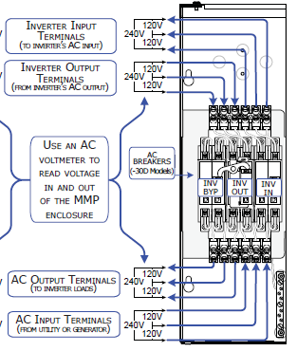

INSTALLING BATTERY MONITOR

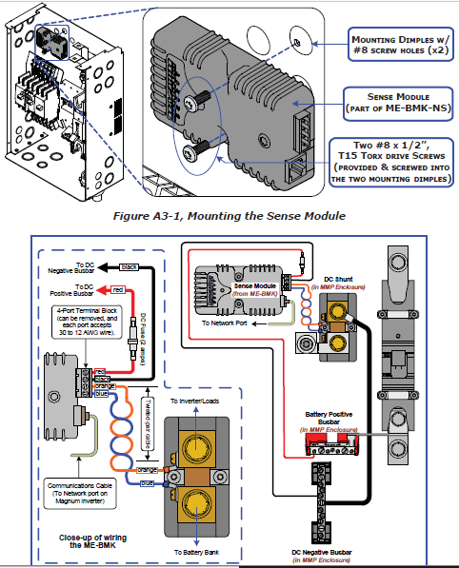

PROGRAMMING SYSTEM CONTROL PANEL

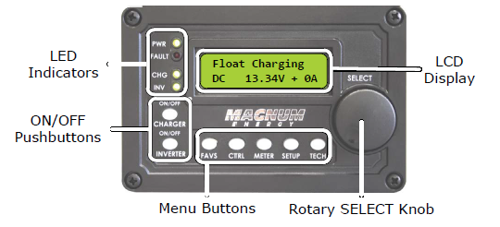

- SET TIME: When the inverter is powered up, the remote will run through an automatic self-test. The remote will then ask you to set the clock. Use the SELECT knob to get to the desired number, then press to set. Once complete, the Inverter Home Screen will show.

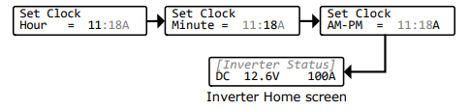
- SET POWER SAVE TO ON: Enable the power save mode to disable the backlight on the remote, this will conserve energy.
- SET TEMP DISPLAY: Set the temperature to Celsius
- INVERT SETUP:
  - Search Watts, set to ON
  - LBCO Setting: 46.0 VDC
  - AC In-Time: SOC Feature should be utilized Connect: 80%, Disconnect: 100%
- CHARGER SETUP:
  - Input Amps: 30A
  - VAC Dropout:
  - Battery Type: AGM1 (see following chart), these values are fixed for the particular model battery, default settings are acceptable.
  - Max Charge Amps:

  - Set CV Charge Volts: 55.2 VDC

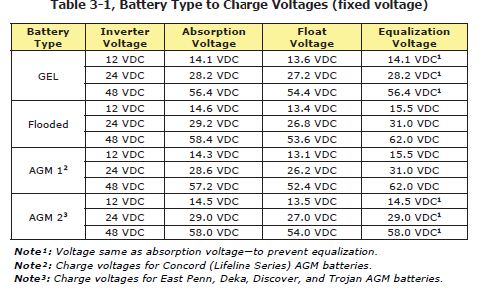

  - Set CV Charge Done: Time, 2.5 hrs
  - Set Recharge Done Amps: 20ADC
  - Set Recharge Done Volts: 48VDC
  - Absorb Done: SOC 100%
  - Max Charge Rate: 46A
  - Final Charge Stage: Float

Refer to the USER MANUAL for additional settings and menu maps for the Magnum ARC-50

MAINTENANCE GUIDE

Exterior Panels
- WEEKLY: Clean off grime or dust from the panel surfaces.
- MONTHLY: Examine the sealing tape to ensure a proper seal is still being maintained.

Interior Panels
- REGULARLY: Wipe the interior panels with clean water and dishwashing liquid. Do not use any chemical cleaners on the silver surface.

Solar Modules
- REGULARLY: Wipe the solar panels clean of dust debris to ensure optimal performance.

Battery Storage:
- REGULARLY: Monitor battery performance and state of charge (SOC) regularly on the system. Report any lack of charging on the maintenance log and to technical support.

Power System:
- REGULARLY: Check online status of solar performance, report any irregularities to DGrid Energy.

Prevention:
- To maintain properly internal cooling temperature, make sure that the door closes each time it is opened.
- Keeping the door shut will prevent condensation and refreezing of water on the unit’s compressor

Roof Panels:
- WEEKLY: Clear off any debris or dust that settles on the roof.
- REGULARLY: Remove any nesting material from animals as soon as it is identified.

Cooling Unit Roof Panel:
- WEEKLY: Keep the Cooling Unit vents clear of any debris or animal nesting

Cool Cube Interior:
- Ensure to keep the door shut to prevent cooling loss.
- DAILY: Keep the floor free of dirt or debris by sweeping with a non-abrasive broom.

Replaceable Items:
- Change the light bulb (Part# _____________) when it fails with one of similar specification.
- Fill up the compressor with the prescribed coolant as per the directions on the unit.

MAINTENANCE LOGS (make copies of this sheet and use weekly)
Week Beginning: ________________________________________________________________
Washed: ________________________________________________________________
Cleared: ________________________________________________________________
Cleaned: ________________________________________________________________
Replaced: ________________________________________________________________
Week Beginning: ________________________________________________________________
Washed: ________________________________________________________________
Cleared: ________________________________________________________________
Cleaned: ________________________________________________________________
Replaced: ________________________________________________________________
Week Beginning: ________________________________________________________________
Washed: ________________________________________________________________
Cleared: ________________________________________________________________
Cleaned: ________________________________________________________________
Replaced: ________________________________________________________________
Week Beginning: ________________________________________________________________
Washed: ________________________________________________________________
Cleared: ________________________________________________________________
Cleaned: ________________________________________________________________
Replaced: ________________________________________________________________

SERVICE LOG (make copies of this sheet and use to report issues)
Detailed Description of Fault
______________________________________________________________________________________________________________________________________________________________________________________________________________________________________________________________________________________________________________________________________________________________________________________________________
Serial Number of Affected Part(s) Repair? Replace?
_________________________________________
_________________________________________
_________________________________________
_________________________________________
Service Contractor
Company Name: Technician’s Name:
Telephone No: Email:

Resolution Status:______________________________________________________________________________________________________________________________________________________________________________________________________________________________________________________________________________________________________________________________________________________________________________________________________

Technical Contacts

DGrid Energy
Call Us: 240-426-9604

Nick Wynne: Chief Technology Officer/Engineer
EMAIL: nwynne@dgridenergy.com

Sequoya Cross: Solar Operations
EMAIL: scross@dgridenergy.com

